UML - Statechart Diagrams

Project: EasiLendar

The Very Best Meeting Planer

Creator: Cat Can

Last update: 06/05/2015

Table of Contents

I. Loading Statechart diagram 3

II. Sign in Statechart diagram 4

III Home Statechart Diagram 5

III Single searching Statechart Diagrams 6

III Group searching Statechart Diagrams 7

IV Database Statechart Diagrams 8

1. View profile Statechart diagram 8

2. Friend request Statechart diagram 9

3. Friend delete Statechart diagram 10

4. Friend accept Statechart diagram 11

V. Setting Statechart diagram 12

VI To-do Statechart diagram 13

1. Main diagram 13

2. Important, Very Important, Recently diagram 14

3. Done list diagram 15

4. Checklist diagram 16

VII My profile Statechart diagram 17

VIII Share Statechart diagram 18

IX Get Device information Statechart diagram 19

X Export Statechart diagram 20

# I. Loading Statechart diagram

# II. Sign in Statechart diagram

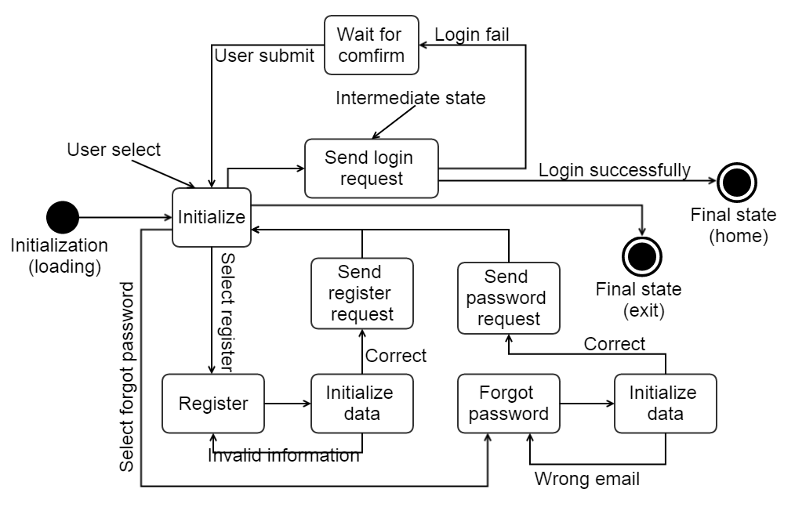

# III Home Statechart Diagram

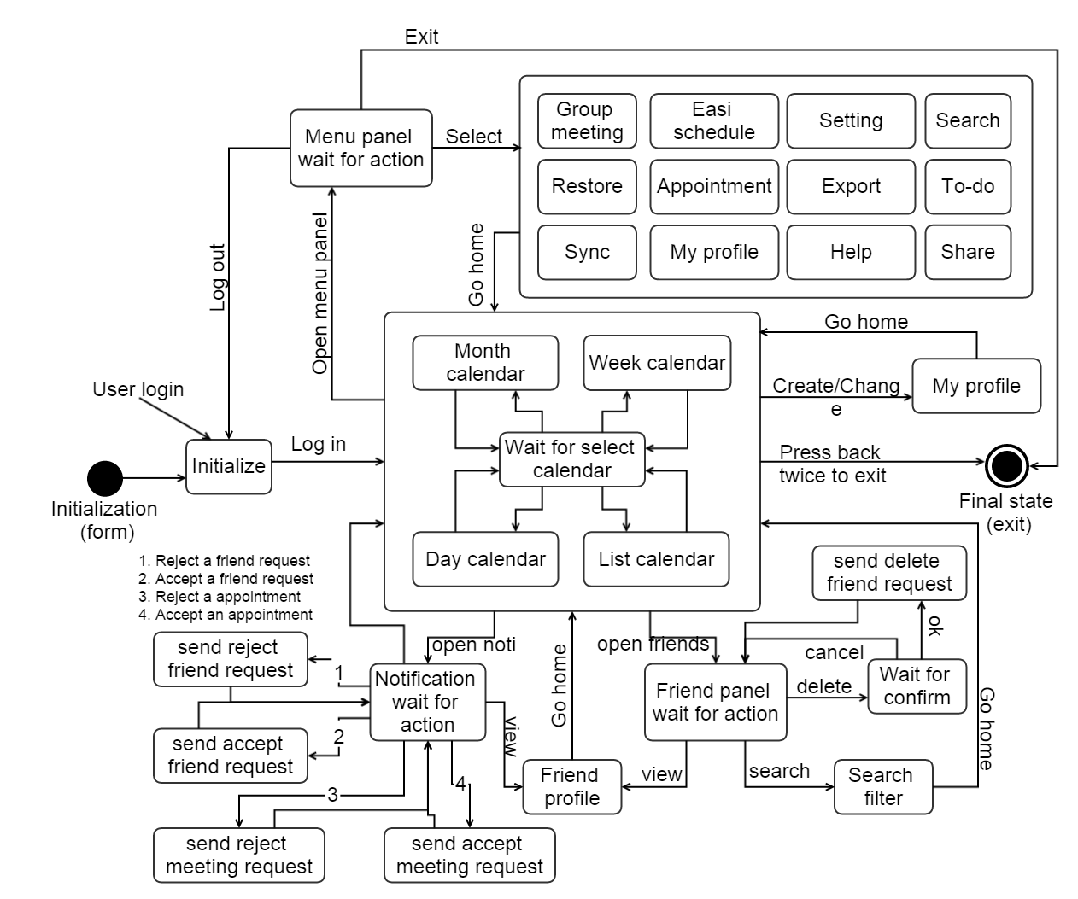

# III Single searching Statechart Diagrams

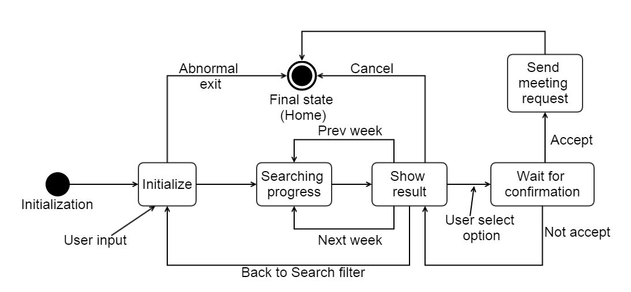

# III Group searching Statechart Diagrams

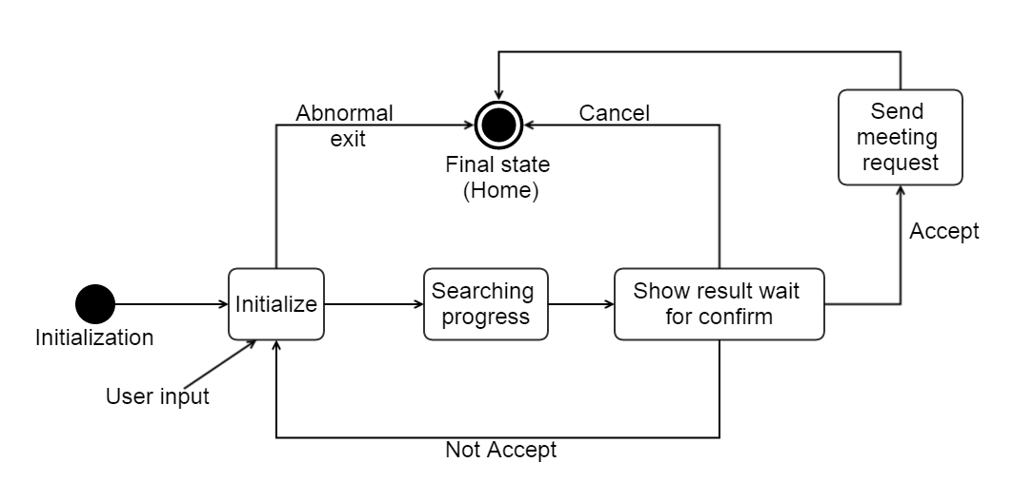

# IV Database Statechart Diagrams

## 1. View profile Statechart diagram

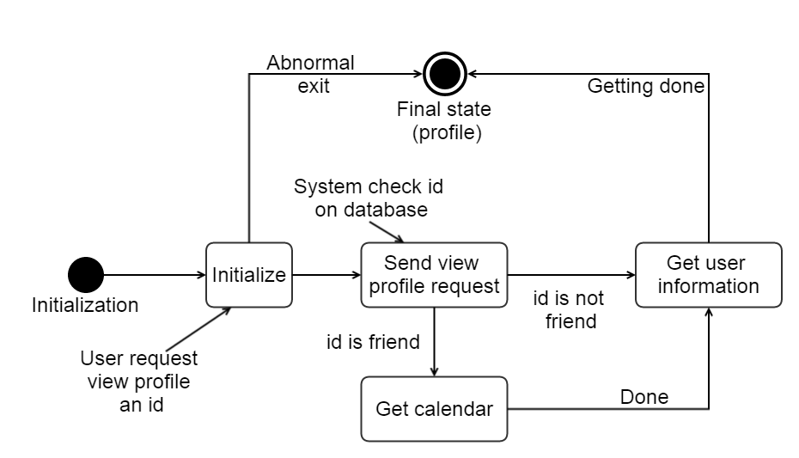

## 2. Friend request Statechart diagram

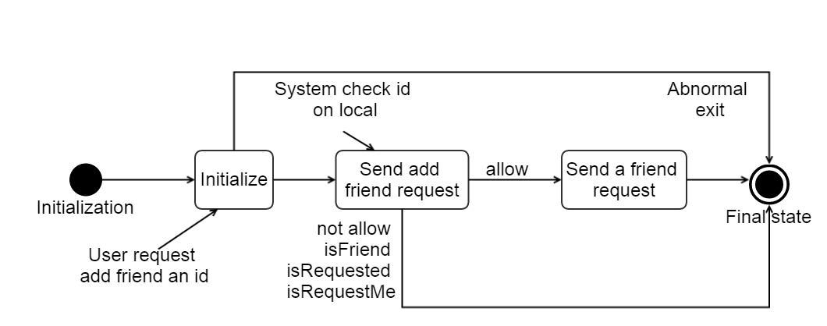

## 3. Friend delete Statechart diagram

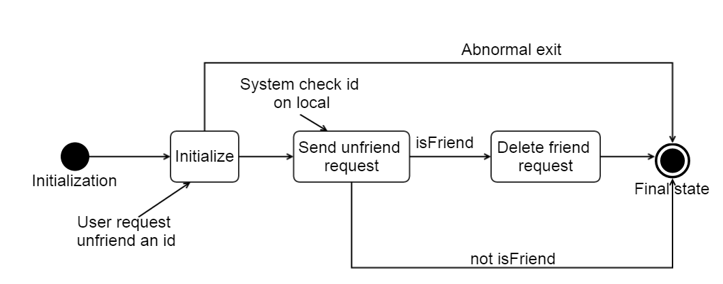

## 4. Friend accept Statechart diagram

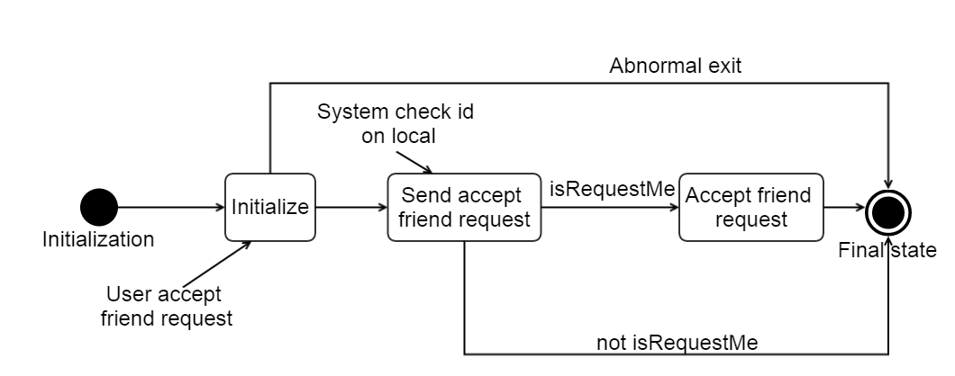

# V. Setting Statechart diagram

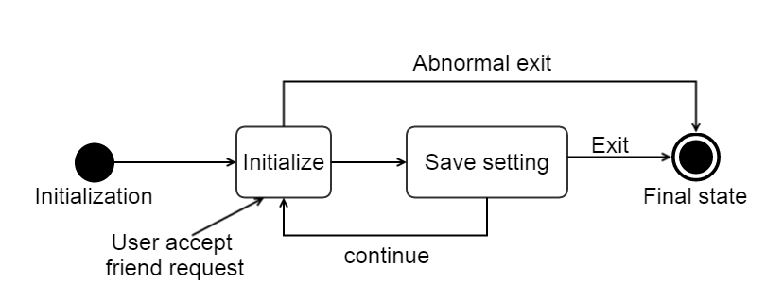

# VI To-do Statechart diagram

## 1. Main diagram

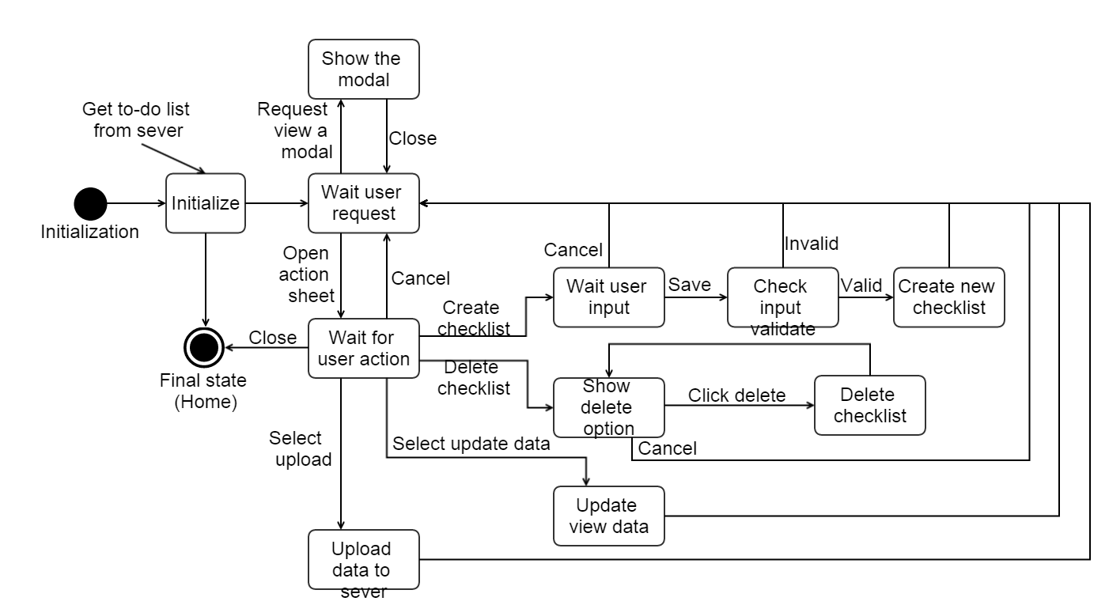

## 2. Important, Very Important, Recently diagram

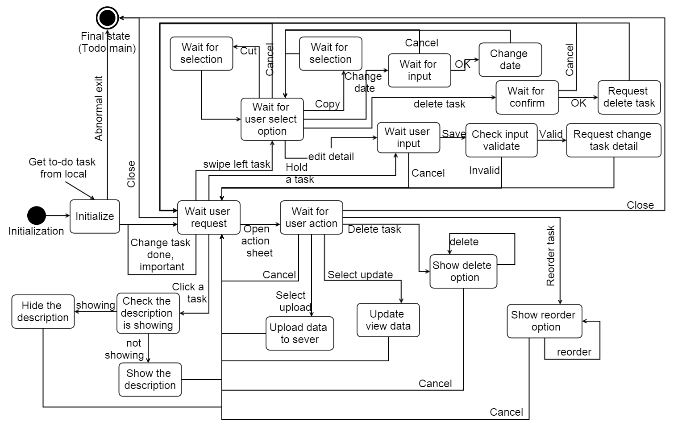

## 3. Done list diagram

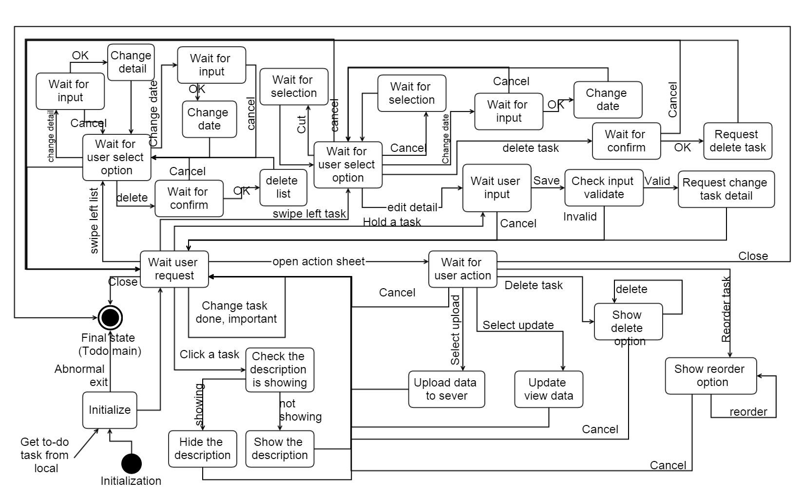

## 4. Checklist diagram

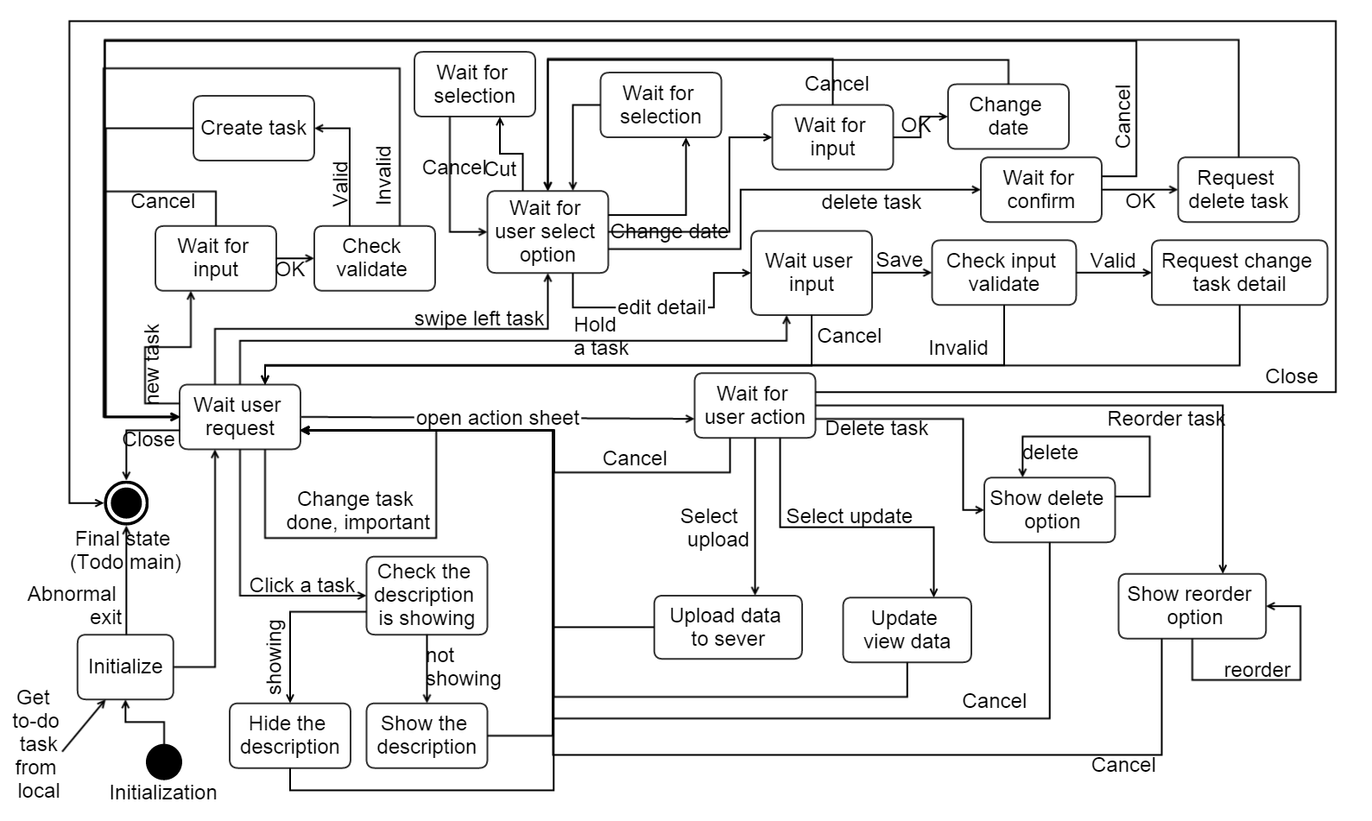

# VII My profile Statechart diagram

# VIII Share Statechart diagram

# IX Get Device information Statechart diagram

# X Export Statechart diagram